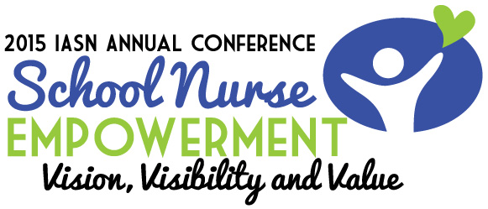

Additional hotel information in Oakbrook:

The hotel block for IASN at the DoubleTree, site of the 2015 conference is full.
However, here are some alternatives:
The DoubleTree shuttle will go within 5 miles of the hotel. Listed below are some hotels that you can call and check for availability. Most of the hotels in the area also have shuttles that can take guests back and forth.

Hilton Garden Inn Chicago/Oakbrook Terrace (630) 941-1177
Le Méridien Chicago - Oakbrook Center (630) 368-9900
Hilton Chicago/Oak Brook Suites (630) 941-0100
The Drake Oak Brook Hotel 630) 571-0000
Holiday Inn Chicago Oakbrook (630) 833-3600

